Owl Pellet Dissection

Bone Identification
We recently dissected an owl pellet (you can watch the video and see bigger photos here) and I have taken close up photos of some of the bones so that you can identify them too. Any pics with more than one bone in are those that I think are the same type of bone. I don’t know what this animal is, so can’t give any definite answers, we’re all exploring this together.
Here are a couple of guides which may be helpful:
The Natural History Museum Beginner’s Guide to Identifying British Mammal Bones
https://www.nhm.ac.uk/content/dam/nhmwww/take-part/identify-nature/british-mammal-bones-ID-guide.pdf
The Barn Owl Trust Owl pellet contents: small mammal bone identification guide
https://www.barnowltrust.org.uk/sitemap/galleries/pellet-analysis/
This worksheet can be printed or filled in digitally to save paper (just tap the writing in the box and type). The ruler is in cm and mm. I would love to hear about your findings and if you enjoyed it, drop me an email at jane@beneaththebadgertree.com and tell me all about it.
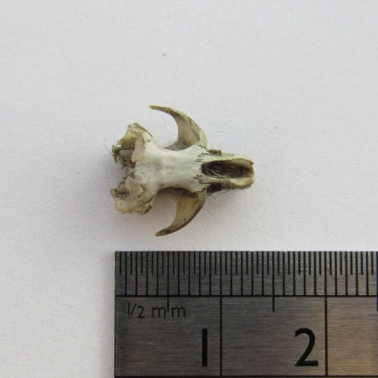  1 | 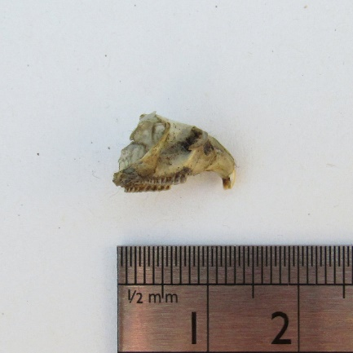 | 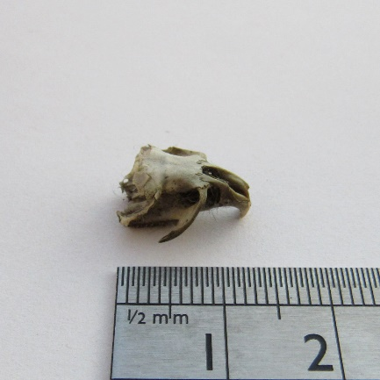
What bone do you think this is?
What animal do you think this is?
Notes

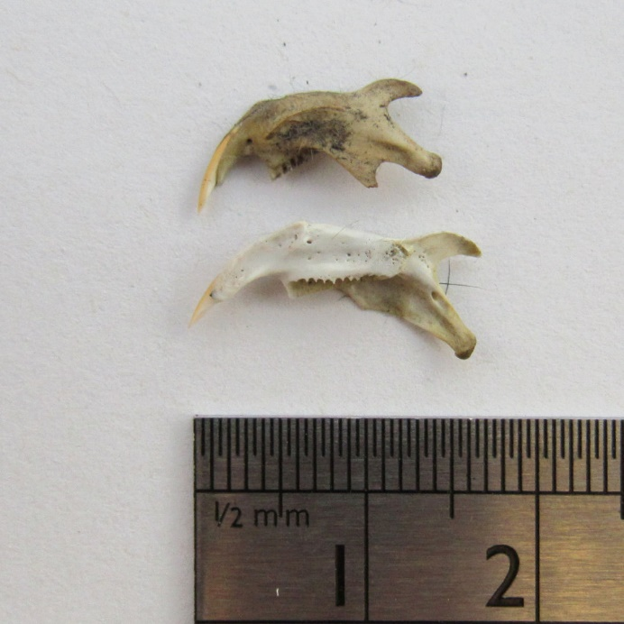  2 | 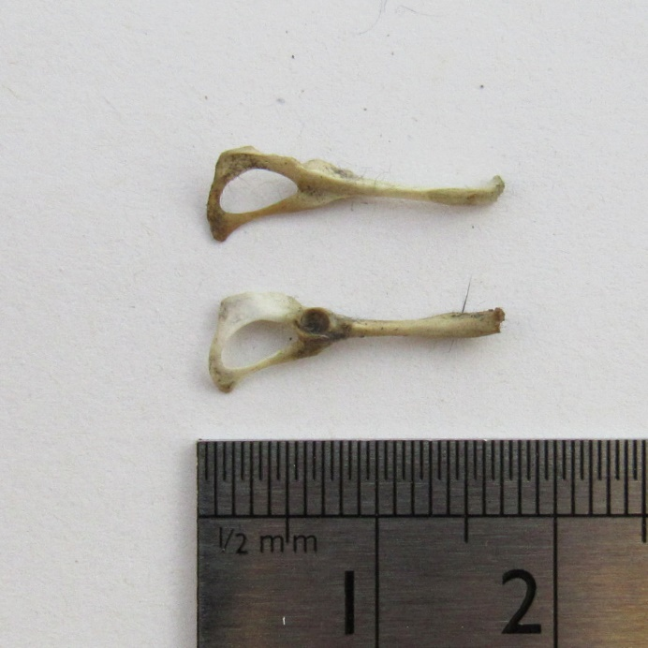  3
What bone is this? | What bone is this?
Notes | Notes
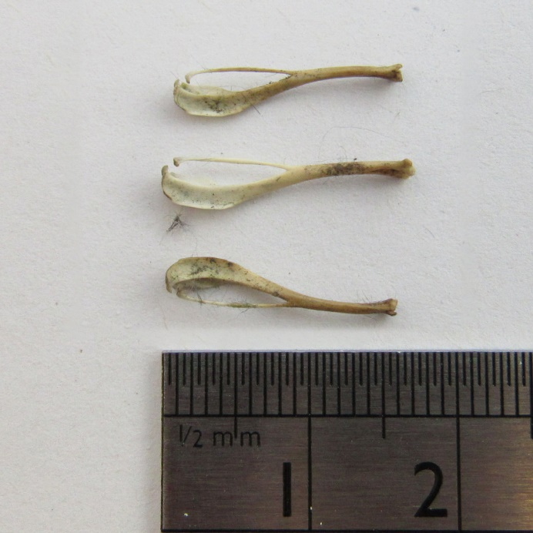  4 | 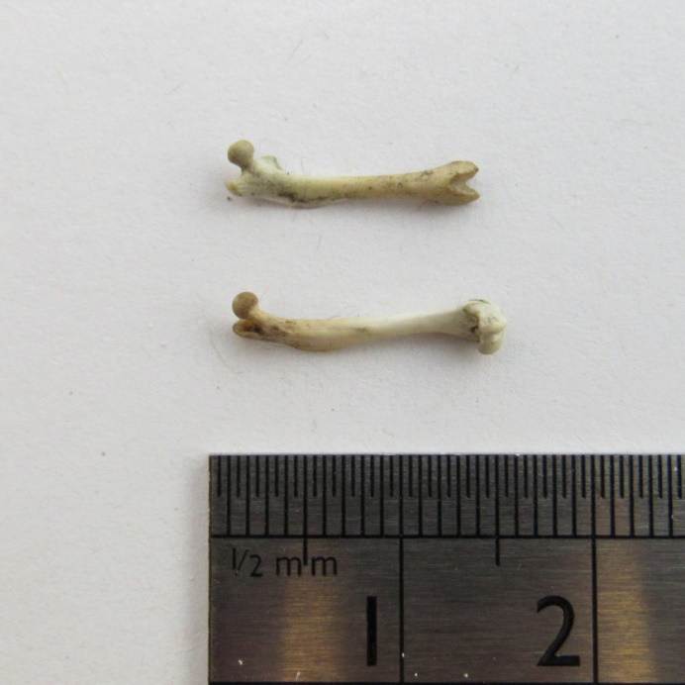  5
What bone is this? | What bone is this?
Notes | Notes

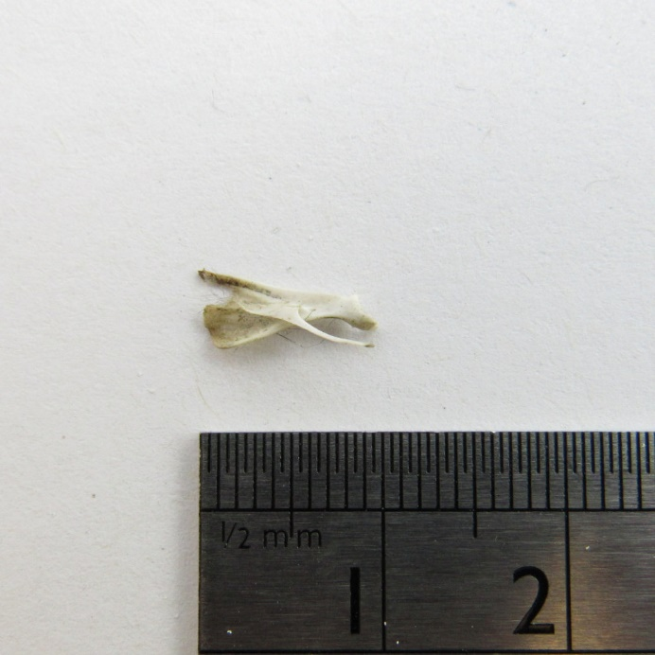  6 | 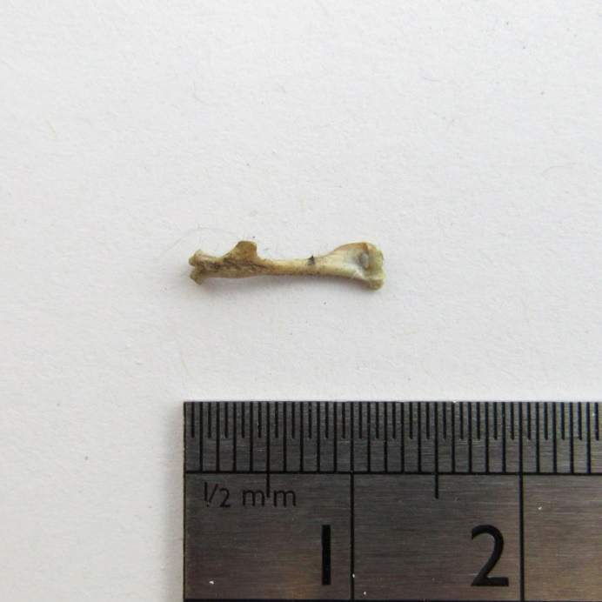  7
What bone is this? | What bone is this?
Notes | Notes
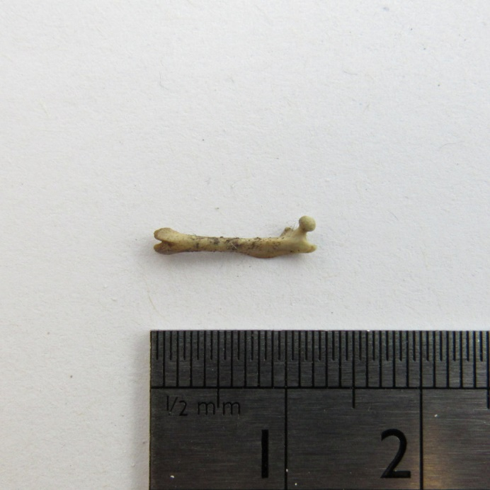  8 | 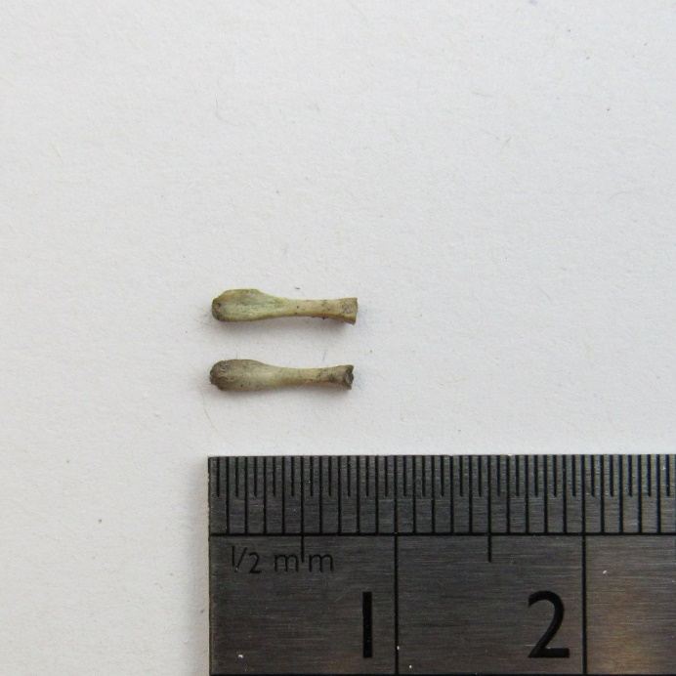  9
What bone is this? | What bone is this?
Notes | Notes

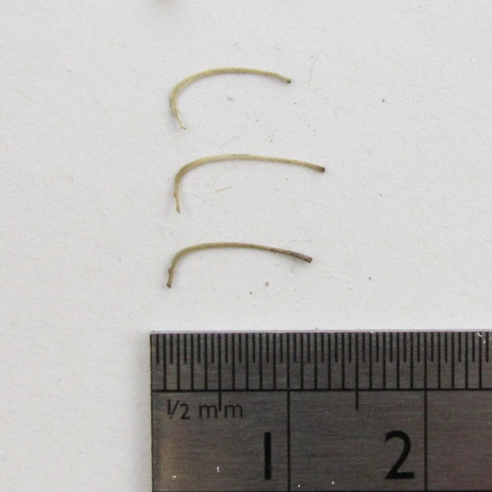  10 | 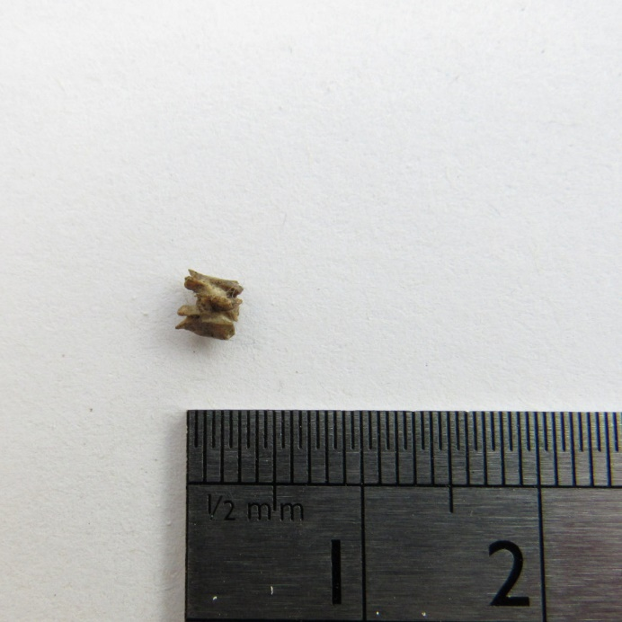  11
What bone is this? | What bone is this?
Notes | Notes
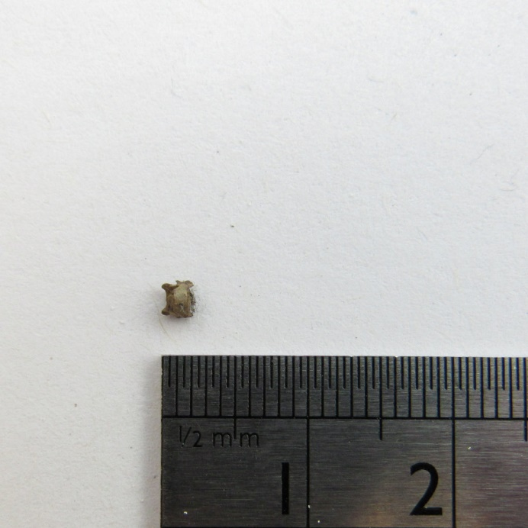  12 | 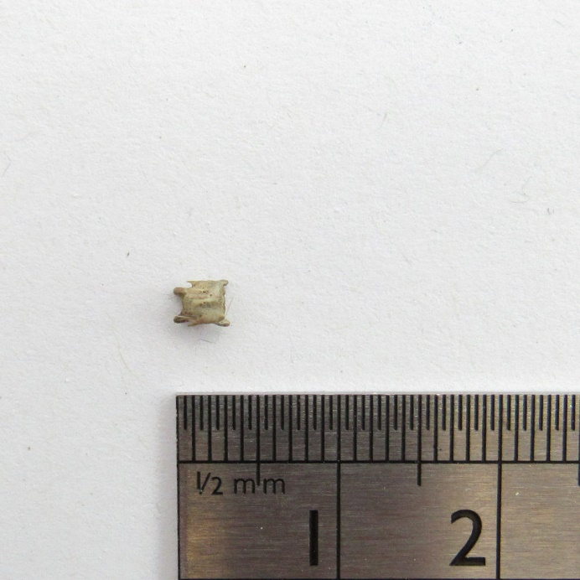  13
What bone is this? | What bone is this?
Notes | Notes

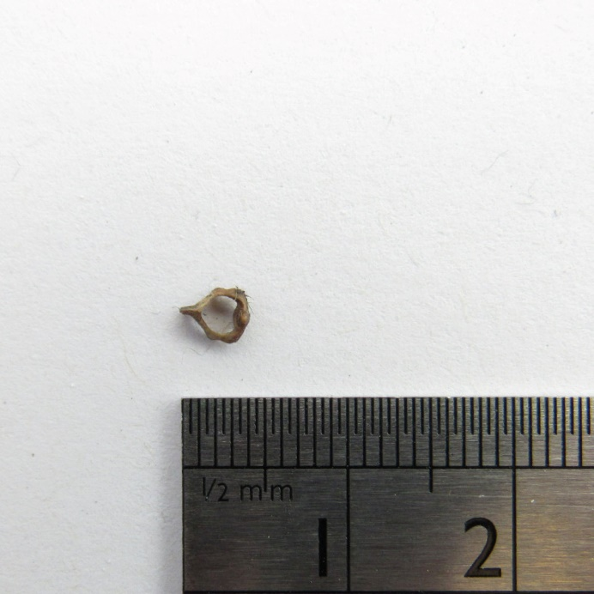  14 | 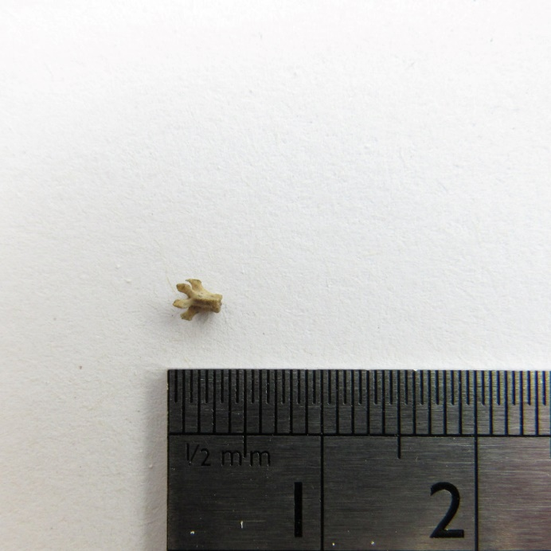  15
What bone is this? | What bone is this?
Notes | Notes
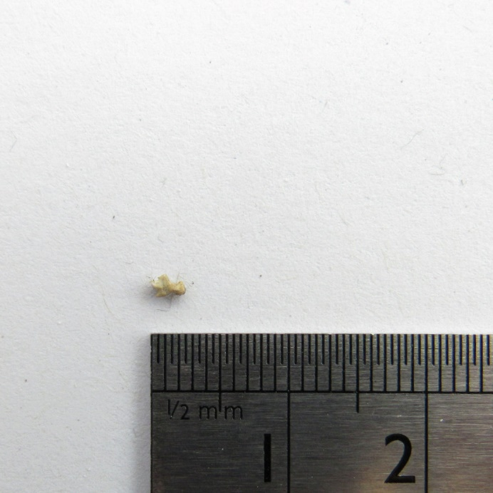  16 | 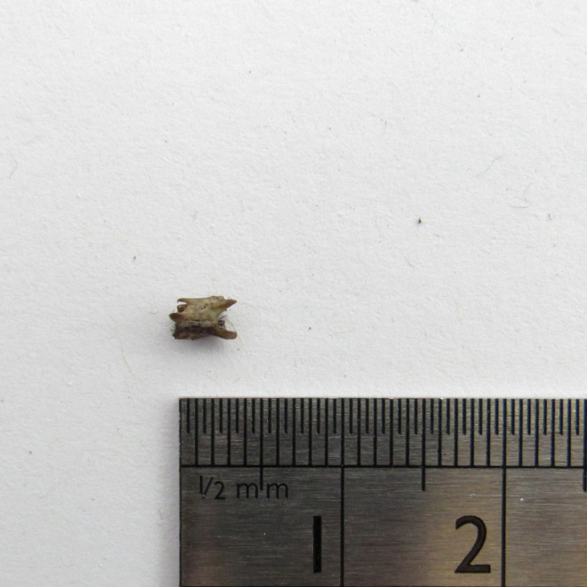  17
What bone is this? | What bone is this?
Notes | Notes

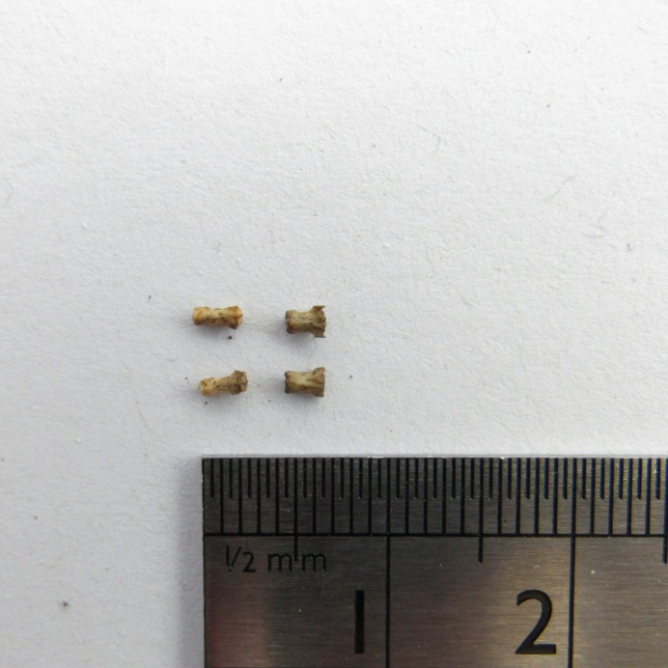  18 | 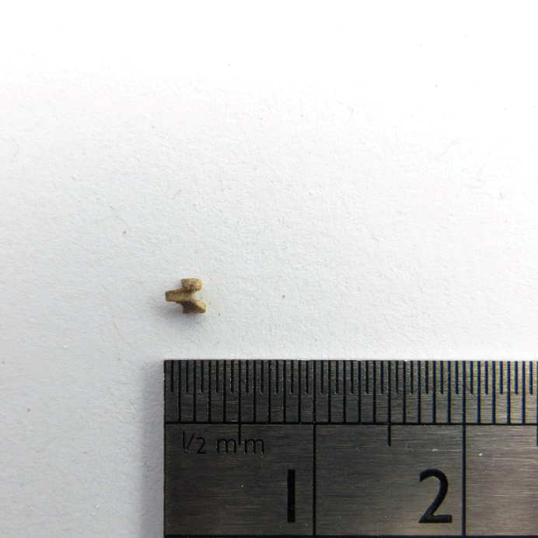  19
What bone is this? | What bone is this?
Notes | Notes
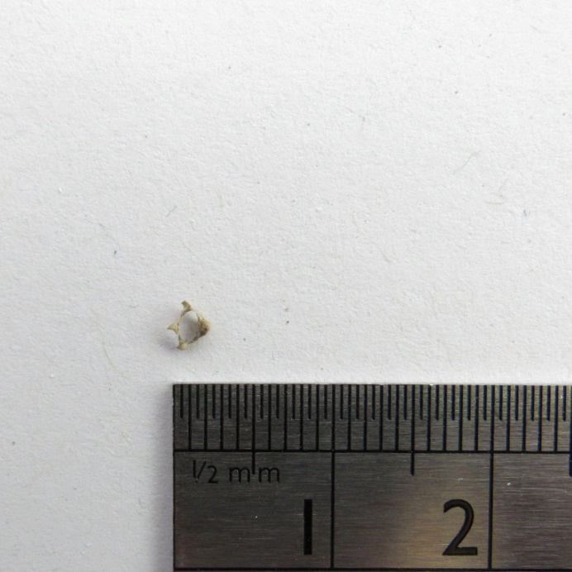  20 | Can you draw one of the bones?
What bone is this?
Notes

